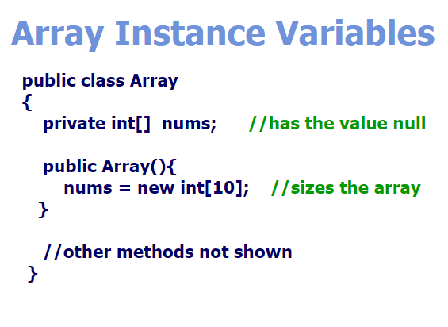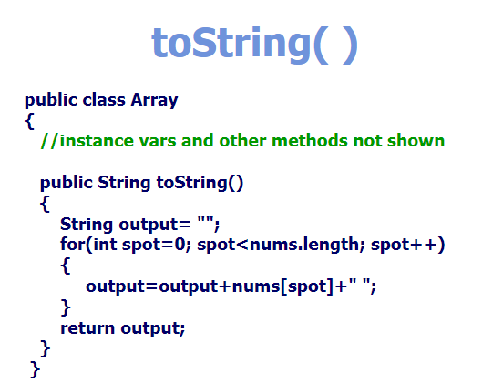

\*\*MUST SIZE THE ARRAY IN THE CONSTRUCTOR